**Hipparcos star dataset**

**Problem Statement**  
This data set pertains to astrophysics and can be extended to business applications also. We used exploratory techniques to identify 92 stars from the [Hipparcos](http://astrostatistics.psu.edu/datasets/HIP_star.html) data set that are associated with the Hyades. We did this based on the values of right ascension, declination, principal motion of right ascension, and principal motion of declination. We then excluded one additional star with a large error of parallax measurement: Use a t-test.

**Astronomical background**

The key to understanding the properties and evolution of stars is the Hertzsprung-Russell diagram, first studied around 1910.  It plots the luminosity of stars along the ordinate, and the color of stars along the abscissa.  When a random selection of bright stars is plotted, one sees the "main sequence" of hydrogen-burning stars and the later "red giant" stars burning helium and other nuclei.  The main sequence is most clearly seen when the stars in a coeval (= born together), codistant "open cluster" of stars are plotted.  The nearest open cluster is the Hyades cluster and its HR diagram has been carefully studied for many years (e.g. **[Pinsonneault et al. 1998](http://www.journals.uchicago.edu/ApJ/journal/issues/ApJ/v504n1/37753/37753.pdf)**).

The main difficulty in establishing the HR diagram for a sample of stars is determining their distances.  For nearby stars, this can be done with extremely precise measurements of their positional motion every year as the Earth orbits the Sun.  This is called the parallax.  In the 1990s, the European Space Agency launched a satellite called Hipparcos that measured stellar parallaxes with more precision than previously achieved for ~100,000 stars.  The Hipparcos catalog is thus often used for HR diagram studies. Bright Hyades members have a mean parallax of 22 mas in the Hipparcos database corresponding to a distance of 45 pc.  A famous study of the Hyades cluster using Hipparcos data has been made by [**Perryman et al. (1998)**](http://aa.springer.de/papers/8331001/2300081.pdf).

**Dataset**

We have extracted a subset of 2719 Hipparcos stars which include many Hyades members with the selection criterion that the parallax lie between 20 and 25 mas (i.e. Hipparcos stars with distances 40-50 pc).  The extraction was made using the [**Vizier catalog**](http://vizier.u-strasbg.fr/viz-bin/VizieR?-source=I/239/hip_main) service.  The file was manually edited a bit to give a convenient format & header resulting in the tab-separated ASCII file [**HIP_star.dat**](https://astrostatistics.psu.edu/datasets/HIP_star.dat).

This dataset has the following columns:

1. HIP = Hipparcos star number
2. Vmag = Visual band magnitude.  This is an inverted logarithmic measure of brightness
3. RA = Right Ascension (degrees), positional coordinate in the sky equivalent to longitude on the Earth
4. DE = Declination (degrees), positional coordinate in the sky equivalent to latitude on the Earth
5. Plx = Parallactic angle (mas = milliarcsseconds).  1000/Plx gives the distance in parsecs (pc)
6. pmRA = Proper motion in RA (mas/yr).  RA component of the motion of the star across the sky
7. pmDE = Proper motion in DE (mas/yr). DE component of the motion of the star across the sky
8. e_Plx = Measurement error in Plx (mas)
9. B-V = Color of star (mag)

The HR diagram can be plotted by plotting logL vs. B-V where (roughly) the log-luminosity in units of solar luminosity is constructed logL=(15 - Vmag - 5logPlx)/2.5.  All logs are base-10.

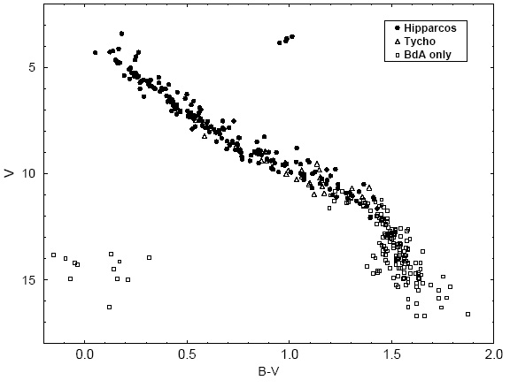

The plot above from [**Perryman et al. (1998)**](http://aa.springer.de/papers/8331001/2300081.pdf) shows the HR diagram of the Hyades from Hipparcos data once Hyades members are discriminated from background stars.  It is tricky to select out Hyades members in a reliable and complete fashion.  Their sky positions are centered around RA=67 degrees & DE=+16 degrees, but they also share converging proper motions with vector components pmRA and pmDE.

**Statistical exercises**

* Find Hyades cluster members, and possibly Hyades supercluster members, by multivariate clustering.
* Validate the sample, and reproduce other results of [**Perryman et al. (1998)**](http://aa.springer.de/papers/8331001/2300081.pdf)
* Construct the HR diagram, and discriminate the main sequence and red giant branch in the full database and Hyades subset.  Can anything be learned about the `red clump' subgiants?
* Isolate the Hyades main sequence and fit with nonparametric local regressions and with parametric regressions.
* Use the heteroscedastic measurement error values e_Plx to weight the points in all of the above operations.
* Can any unusual outliers be found? (white dwarfs, halo stars, runaway stars, ...)